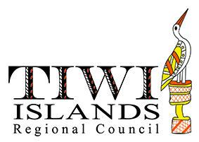

**Job Opportunity Office Coordinator - Wurrumiyanga**

What will I be doing?

* Supervision, instruction and on-the-job training of receptionist
* Ensure the Council office is adequately staffed at all times includes backfilling.
* Ensure efficient communications and quality customer services.
* Acquisitioning of stationery supplies, furniture and equipment where required.
* Ensure a safe, healthy working environment.
* Provide administrative support to Directors/Officers.
* Provide administrative support to Local Authorities.
* Supervise cash handling procedures including reconciliation and banking.
* Provide Community Services support.
* Mentor local employees and identify potential employees.
* Other tasks as requested by CEO.
* Wurrumiyanga
* Full time
* Monday to Friday, 7.6 hours per day

What are we looking for?

1. Demonstrated experience in office management and customer relations.
2. Demonstrated experience in working with Aboriginal people in remote areas or in a situation requiring cultural sensitivity.
3. Proven ability to supervise, instruct and train employees.
4. Demonstrated ability to establish and maintain office administration systems, procedures and practices that are effective and efficient.
5. Proficiency in computer and IT use including Microsoft office systems (e.g Word, Excel) records management and data collection systems.
6. Experience in cash handling
7. Current NT Driver’s Licence

I’m interested. What do I do next?

* Come to the Council and ask for an employment pack
* Submit an application form, along with your resume and selection criteria
* Ask to speak to someone in Human Resources if you want to find out more
* Human Resources can be contacted on 8970 9523

Applications close 5pm Friday 2 November